SI 206

Final Project: [**https://github.com/dhwray1/206-final-proj.git**](https://github.com/dhwray1/206-final-proj.git)

Anjali Francis, Dhwani Rayathatha, Vikram Reddy

12/9/22

**SI 206 Final Project**

As college students, we understand how hard it is to find time to find healthy ingredients and be able to understand what goes into our food. We wanted to be able to create a project that we can learn from and use, after our time in SI 206. We sought to create a project that uses three API’s that focuses on three main goals: finding healthy ingredients by looking at nutrient information, finding meals that one can make with these ingredients, and finding wines that pair well with a lot of food meals. As everyone is above twenty-one years old, we want to be able to improve our diets and have some ideas on how to prepare some meals as we move on from college and onto our jobs. Likewise, as college students who have limited budgets, we are interested in getting an idea of which ingredients can produce a variety of meals.

**Goals We Achieved**

We achieved the ability to understand nutrient information and specifically focus on what constitutes healthy ingredients. We were able to look through many meals, look at what made up those meals and be able to understand if those specific nutrients are good for us as we become older. We looked at different ingredients such as eggs, mushrooms and chicken and then were able to calculate the total amount of calories. For example, we were able to look at chicken and then understand its nutritional data such as its protein, fat and carbohydrate contents. Another goal we achieved was finding and creating new dishes with these new-found ingredients. For example, we used our MealDB API, to find meals that we can make with these specific ingredients. We imputed the word “Chicken”, and were immediately able to see nine meals that we could make at home. Finally, we also achieved the ability to learn what meals pair best with different types of white wine. For example, white wine returned “pho”, “fish”, “crab”, “stew” and “carp”. This gave us a big list of meals to choose from and we can even match two or more meals together. Learning how different meals match up with different types of wine, will give us the ability to host events in the future and impress family and friends.

**The problems we faced:**

We had a lot of problems with the Spoonacular API. The biggest problem we faced was being able to pull sufficient data per day from the API. We were limited to 150 pulls per day and only 60 pulls per 60 seconds and that really hindered our ability to collect data. While we contemplated caching the collected data into a json file, we decided to buy an upgraded version of the API, in order to help us get past that threshold. It gave us 1500 pulls per day and pulled five wine names per second and helped fix our request problem. We also faced a similar problem with the Edamam API. We were allowed to only have 4,000 requests per month and often hit the limit as we tried to debug and test code. We fixed this issue by signing up with different emails in order to get different API keys, in order to continue using the API.

**Calculations of Data from the Database**

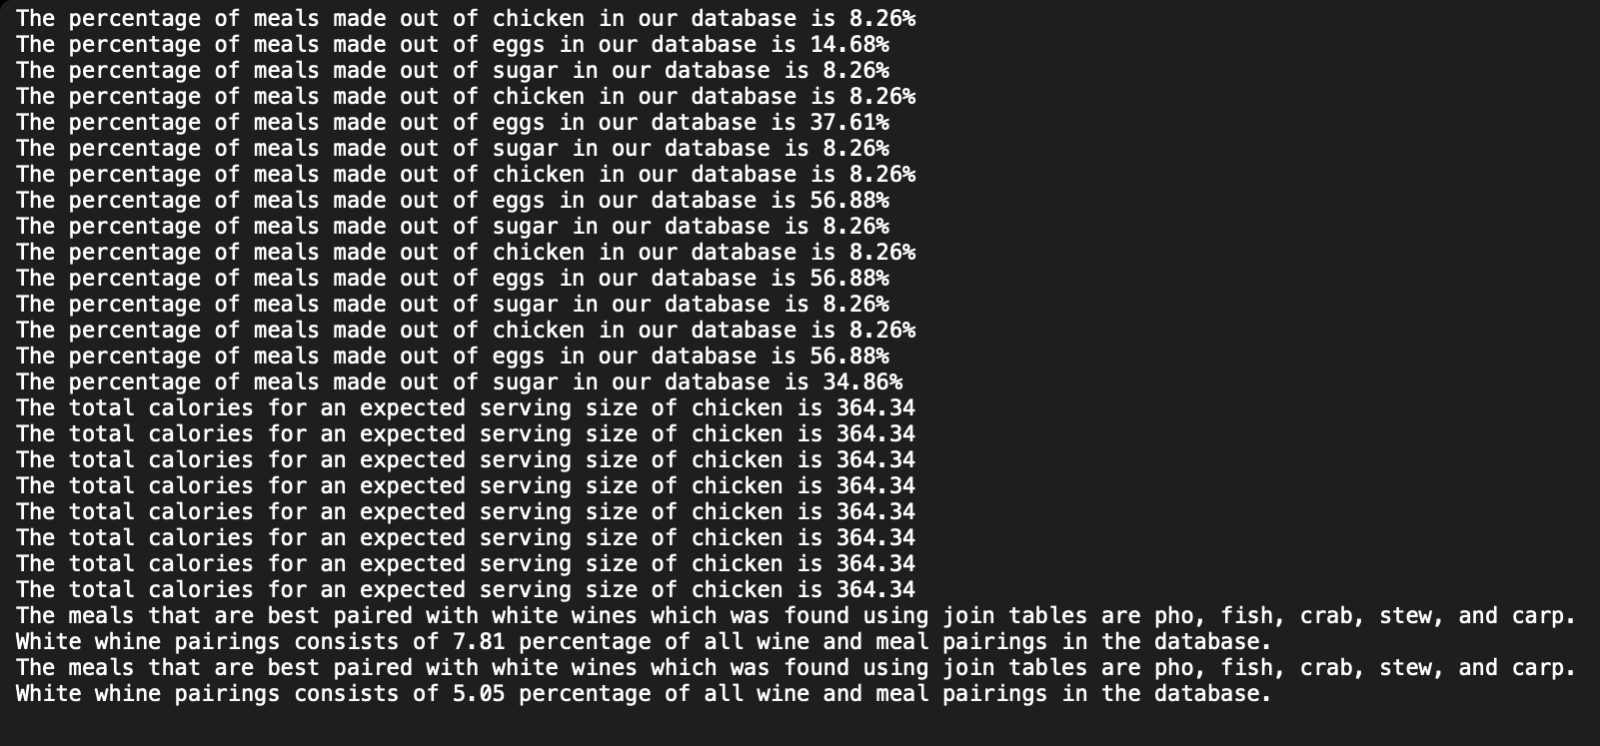

*An image of our txt. file with all the calculations of our data from the database*

**The visualizations that we created:**

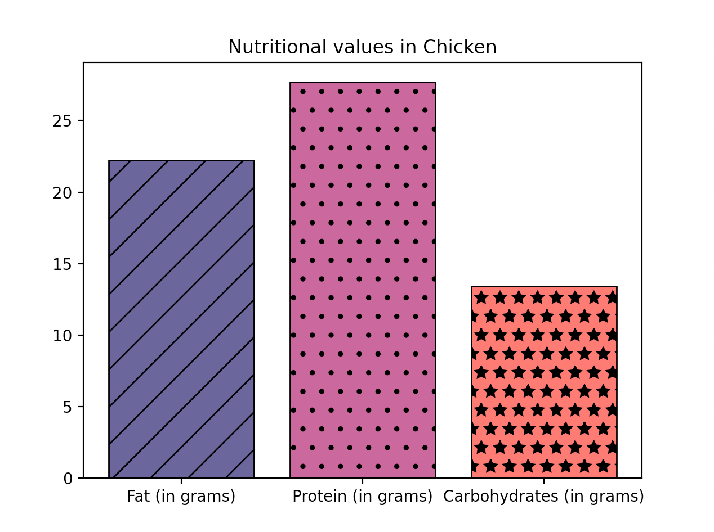

*Bar graph visualization about nutrients in Chicken*

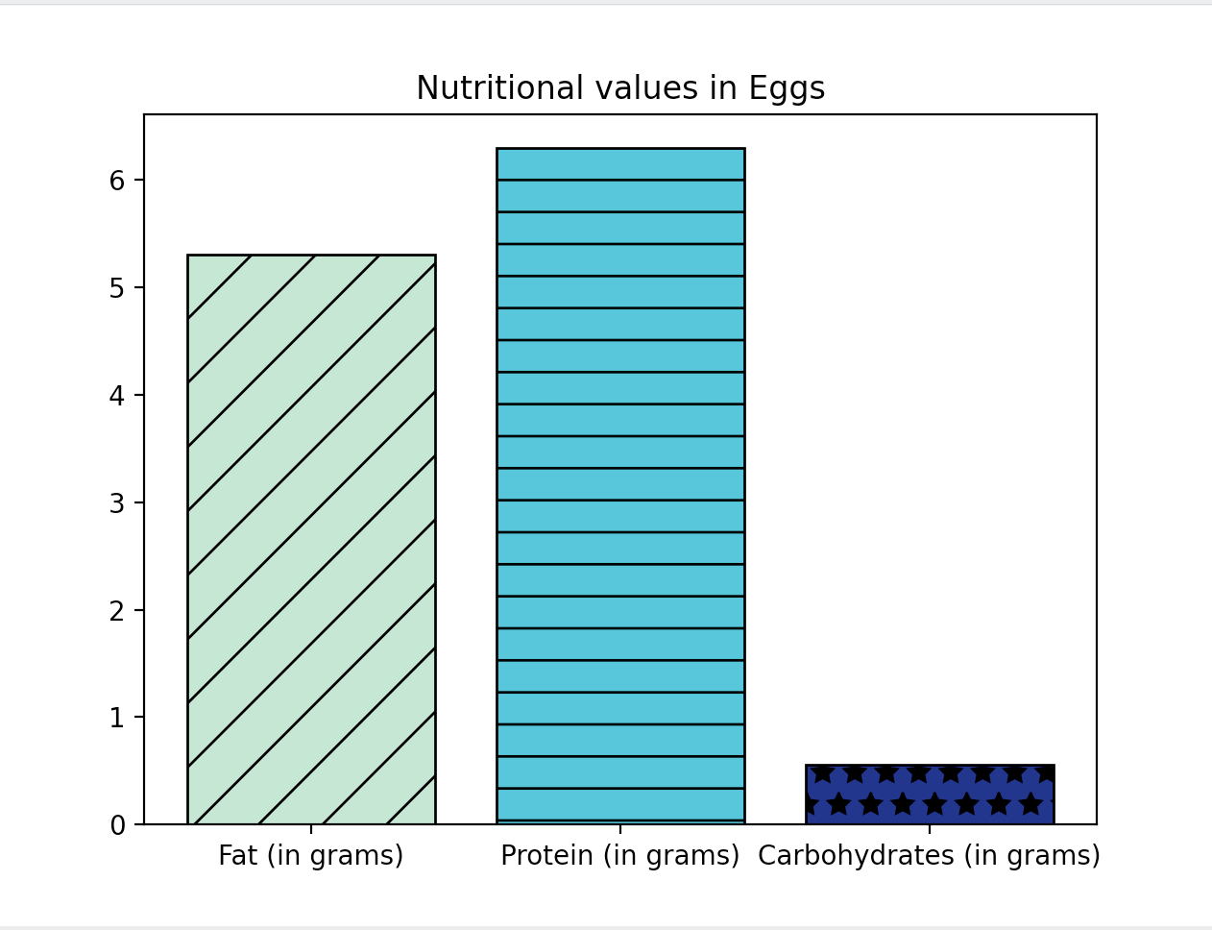

*Bar graph visualization of nutrients found in Eggs*

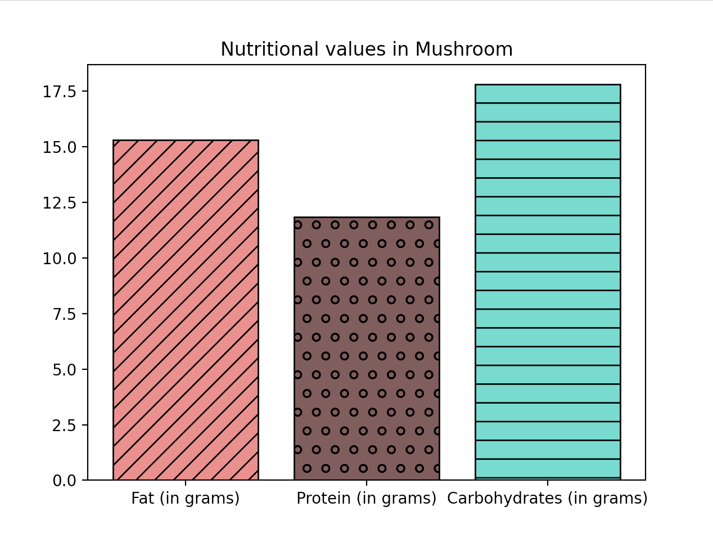

*Bar graph visualization of nutrients found in Mushrooms*

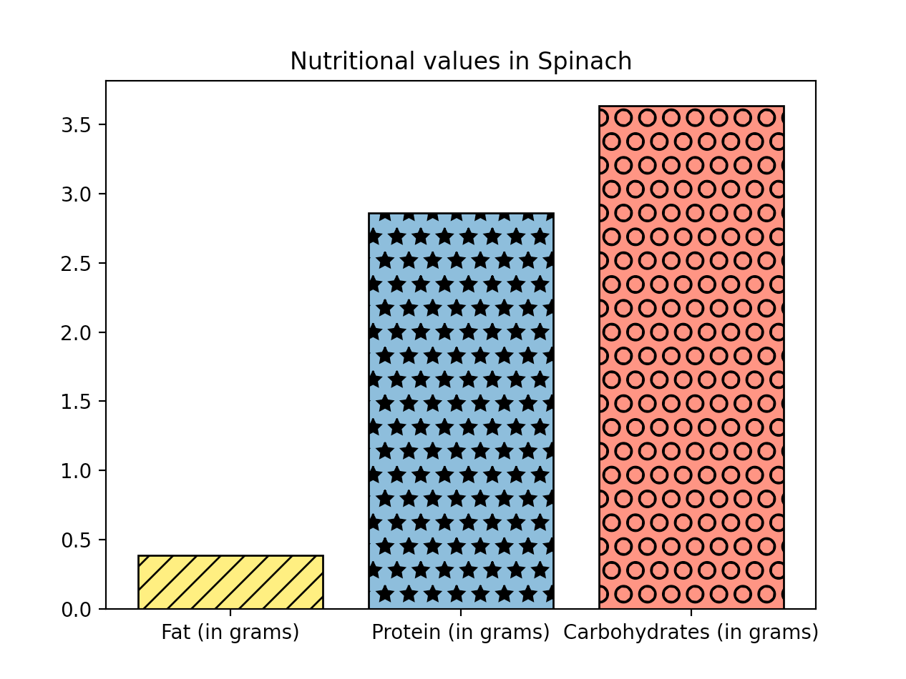

*Bar graph visualization of nutrients found in Spinach*

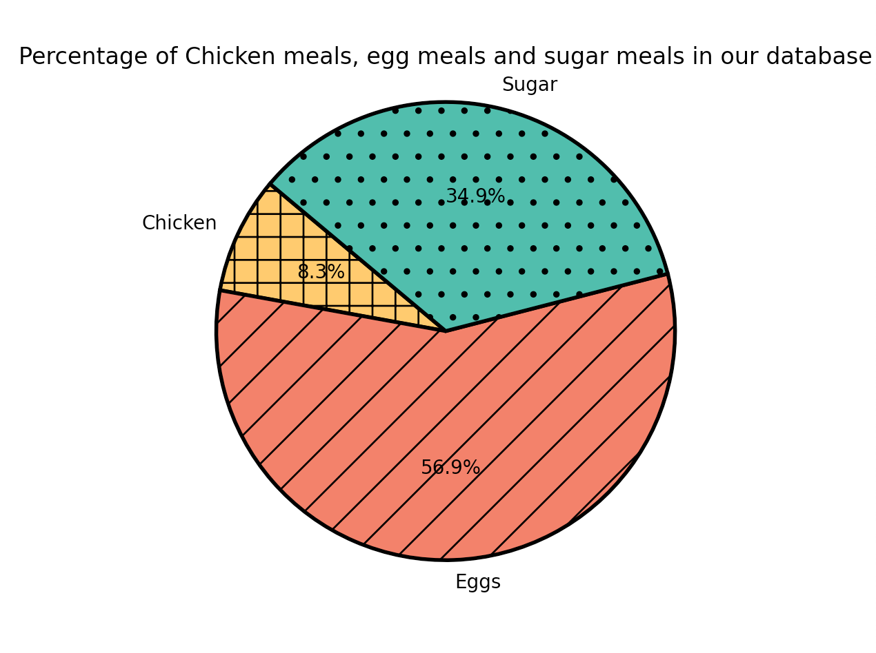

*Pie-chart visualization showcasing the percentage of meals that are made up of three-ingredients: chicken, eggs and sugar*

**Instructions for Running the code**

If the database already exists, please delete the database. Proceed to run each Py. file, 4 times. We run it 4 times as each run gathers 25 items at a time, and we want to reach 100 items. First, run theMealDB py file, then the Nutrtion_API file and finish up with the winepairing pyfile.

Once the MealDB file is run, one pie chart will be generated. After running the Nutrition file, four bar graphs will be generated with unique names and attributes. After running the previous two Py files alongside the winepairing file, a my_file.txt file will be generated containing the calculations from each py file.

**Documentation for each function**

**MealDB.py**

| **Function** | **Description** | **Input** | **Output** |
| --- | --- | --- | --- |
| *Universal code* | There is some code that does not fall under any function that creates a set of dictionaries and lists that we may need to access throughout our file, which is why this is not a separate function by itself. | No input | No particular output |
| *setUpDatabase()* | This function tells the program which path to use and which database to insert data in. This function is in all of our files as we needed each file to add data to the same database. | No input | No particular output |
| *create_meal_table()* | This function creates the table meals in the database and inserts data from the list of dictionaries into the database. | No input | Sets up the tables in the database |
| *calculating_data()* | This function selects the required data and calculates the percentages of each ingredient in our database. | No input | The function prints out the percentages in the terminal output window and also adds this data to our text file. |
| *create_pie()* | This function sets up a pie chart using the data that we calculated |  | Outputs the created pie chart. |

**Nutrition_API.py**

| **Function** | **Description** | **Input** | **Output** |
| --- | --- | --- | --- |
| *Universal code* | There is some code that does not fall under any function that creates a set of dictionaries and lists that we may need to access throughout our file, which is why this is not a separate function by itself. | No input | No particular output |
| *setUpDatabase()* | This function tells the program which path to use and which database to insert data in. This function is in all of our files as we needed each file to add data to the same database. | No input | No particular output |
| *create_fat_table()* | This function creates the table Fat in the database and inserts data about the fat levels from the list of dictionaries into the database. | No input | Sets up the Fat table in the database |
| *create_protein_table()* | This function creates the table Protein in the database and inserts data about the fat levels from the list of dictionaries into the database. | No input | Sets up the Protein table in the database |
| *create_carb_table()* | This function creates the table Carb in the database and inserts data about the fat levels from the list of dictionaries into the database. | No input | Sets up the Carb table in the database |
| *calculating_data()* | This function selects the Protein value, Fat value and Carb value of a specific ingredient in the database and calculates the total number of calories. | No input | The function prints out the calories for the given ingredient and also adds this data to our text file. |
| *create_chicken_bargraph()* | This function sets up a bar graph using the data we retrieved from the API and database | No input | Outputs the created bar chart. |
| *create_egg_bargraph()* | This function sets up a bar graph using the data we retrieved from the API and database | No input | Outputs the created bar chart. |
| *create_spinach_bargraph()* | This function sets up a bar graph using the data we retrieved from the API and database | No input | Outputs the created bar chart. |
| *create_mushroom_bargraph()* | This function sets up a bar graph using the data we retrieved from the API and database | No input | Outputs the created bar chart. |

**winepairing.py**

| **Function** | **Description** | **Input** | **Output** |
| --- | --- | --- | --- |
| *Universal code* | There is some code that does not fall under any function that creates a set of dictionaries and lists that we may need to access throughout our file, which is why this is not a separate function by itself. | No input | No particular output |
| *setUpDatabase()* | This function tells the program which path to use and which database to insert data in. This function is in all of our files as we needed each file to add data to the same database. | No input | No particular output |
| *create_wine_table()* | This function creates the wine tables in the database and inserts data from the list of dictionaries into the database. | No input | Sets up the tables in the database |
| *calculate_data()* | We do our select and Join statements here and we try to find the best paired wines for certain meals. | No input | It adds the meals best paired with specified wine in the text file. |

**Resources**

| **Date** | **Issue Description** | **Location of Resources** | **Result**  **(did it solve the issue?)** |
| --- | --- | --- | --- |
| 12/6/22 | API Request problem for Wine Pairing API | Spoonacular API - Collect Wine names that pair well with food  <https://spoonacular.com/food-api> | It did. We ended up buying a month subscription which helped increase the number of APIs requests and allowed us to test a lot of work |
| 12/7/22 | API Request problem for Nutrition API | Edamam Nutrition Analysis API - Provide nutritional information about expected servicing sizes of ingredients such as fat, protein etc  <https://developer.edamam.com/edamam-nutrition-api> | It worked. We ended up using different emails in order to generate new API keys and that allowed our functions to run properly without any issues |
| 12/7/22 | API Request problem for MealDB API | TheMealDB API- Provide meals that can be made with specific ingredients such as sugar, eggs, and chicken.  <https://www.themealdb.com/api.php> | It did. We also ran into an API request error as we had run out of attempts. We created new accounts in order to get new API keys and were able to run and test our code effectively and efficiently. |
| 12/7/22 | Code for limiting our data being added to the database | UMSI Tutoring ([UMSI Tutoring Directory](https://docs.google.com/spreadsheets/d/11CtKRblVZq3kcsD9Jp99g9GoMChfesv0JnbgZX31cZQ/edit?usp=sharing)) | It did. The tutor helped walk us through the problem and helped debug our code. He taught us how to limit it and helped us understand the concept easily. |